**8050 Foam Kit Installation**

**Speaker Foam Assembly**

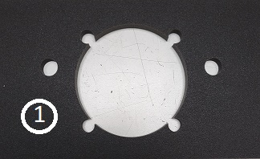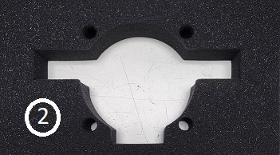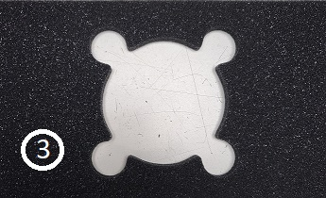

***\*NOTE – Some kits may come with these pieces already assembled as one piece.***

1. **Gently pull speaker foam from the back of back of chamber and unplug.**

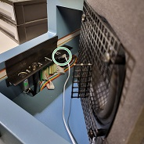

1. **Remove screen and standoff from old foam by removing 4 black screws Do not unscrew Silver screws on back side *\*NOTE – Standoffs are located under screen***

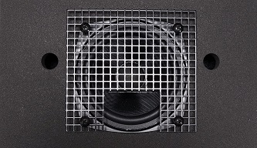

1. **Remove white rods from old foam and install in new foam pieces#1 and #2**

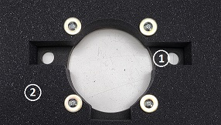

1. **Flip Foam pieces with rods over and feed speaker wire though opening and place body of the speaker and screen on the plastic rods as shown, with cutout/shelf on the bottom**

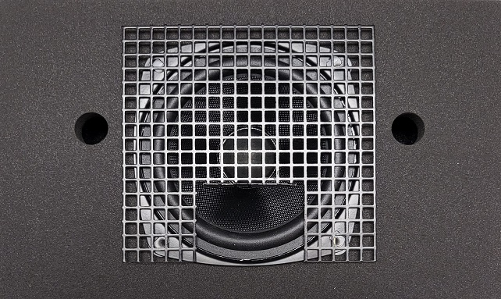

1. **Replace standoffs and black screws as shown.**

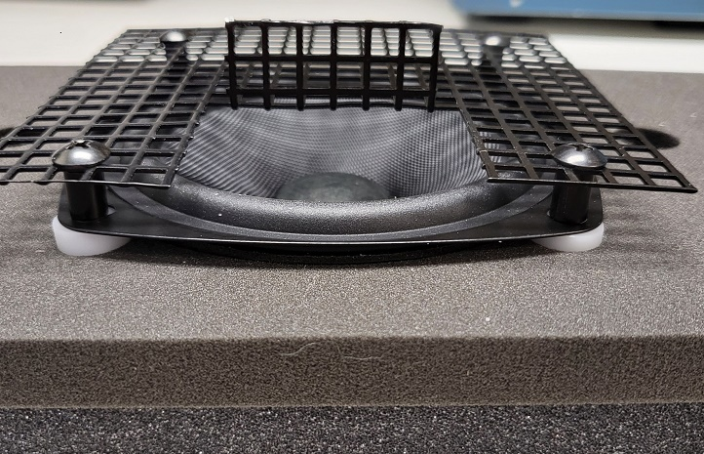

1. **Place Foam piece #3 against back wall of chamber.**

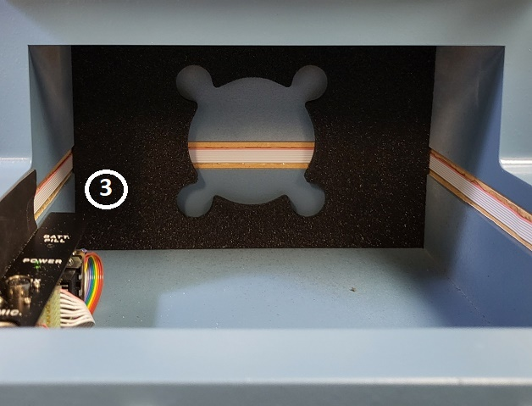

1. **Place speaker assembly in the back of the chamber against foam piece #3 with screen cutout/shelf on the bottom. Hook speaker back up.**

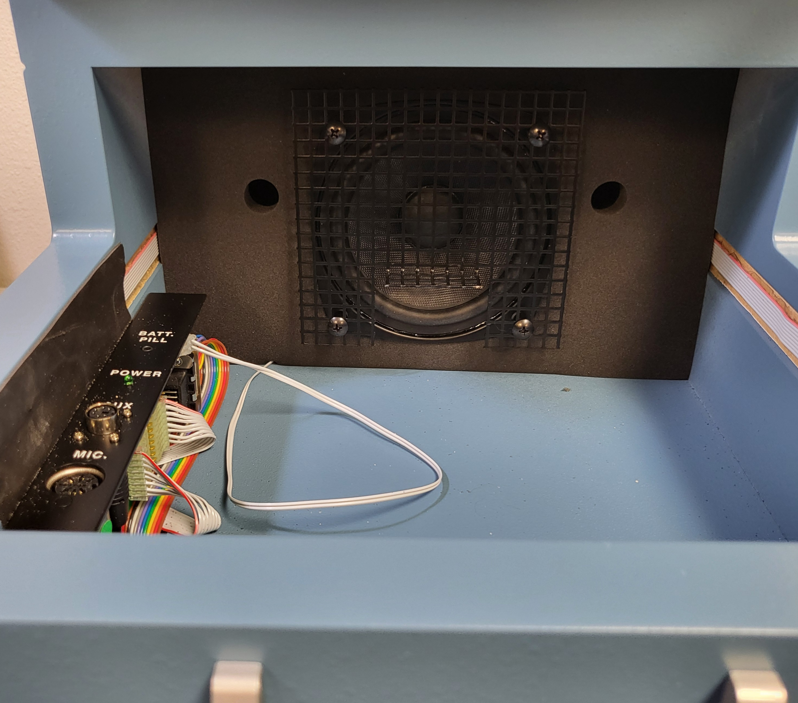

**Lid Seal Kit**

1. **Apply Lid seal kit to inside edge of chamber lid as shown in photo. Long place short strips on top and bottom of lip and long strips on edged.**

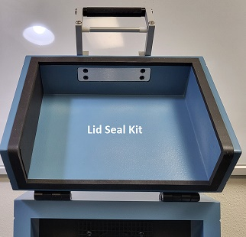

**Chamber Foam**

1. **Place part “A” in bottom of chamber screen cutout/shelf with wedge tips points facing speaker.**

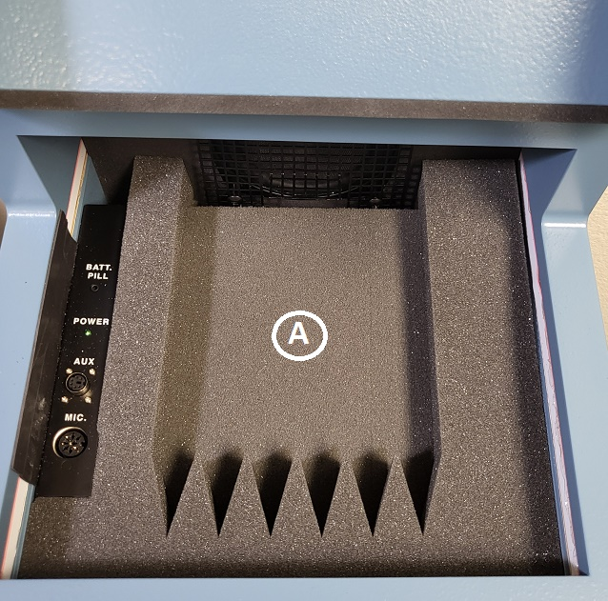

1. **Place part “B” on top of part “A” so it rests on screen cutout/shelf with wedge tips facing speakers.**

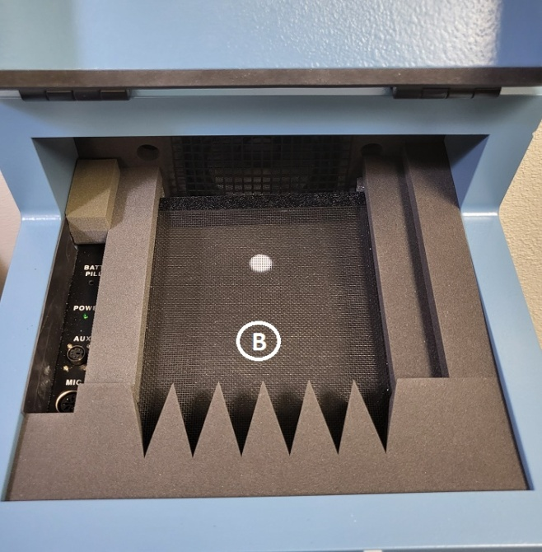

1. **Place “C” in back part of Chamber as shown. Make sure cut out is to the back.**

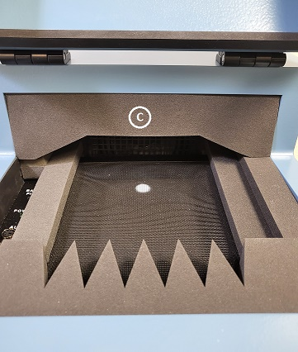

1. **Place “D” in chamber lid with wedge points pointing down**

